REJUVENATE IN BODY & MIND
AT IBIZA RETREATS…
EUROPE’S LEADING WELLNESS DESTINATION

Leading the way in year-round wellness breaks, Ibiza Retreats offers a range of pioneering and truly transforming group and tailor-made retreats for everyone, from burnt out executives to exhausted mums.

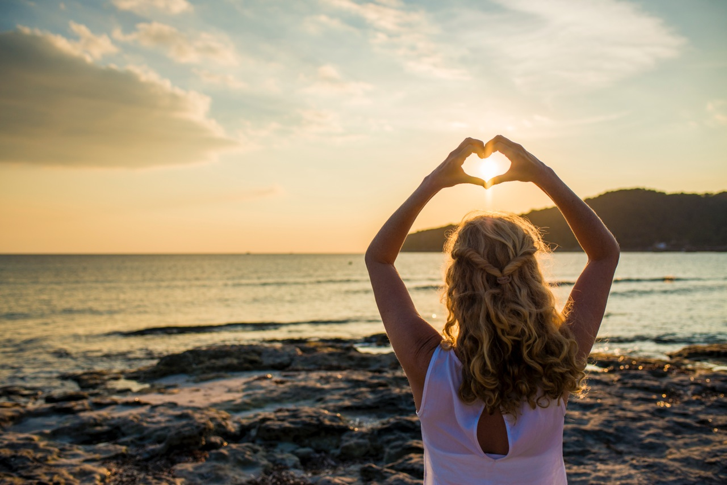
Located just 2.5 hours from London and renowned for its rustic charm and stunning natural beauty, Ibiza has recently emerged as the healing epicentre of Europe.

Ibiza Retreats can now be found in their own beautiful, newly restored finca, Casa Lakshmi Luz, set amidst breath-taking surroundings in the very heart of the island. Boasting tranquil gardens and Moroccan-style swimming pool and individual guest chill-outs, hammocks hosting up to 10 guests to ensure plenty of personal space to relax and restore, as well as personalised support from world-class experts.

So, what sets Ibiza Retreats apart?

Much more than a yoga holiday, the retreats include treatments and workshops which offer deep healing and transformation, mirroring key trends such as mindfulness, digital detox and female empowerment.

Each retreat offers its own USP and a team of more than 50 of Ibiza’s most respected and experienced therapists, ensuring guests receive the very best care. This also extends to ‘after care’, incorporating a ‘back to life’ strategy and follow-up support, helping guests to embrace their wellness and retain healthier habits long after they have left the island.

Founded in 2007 by British born Larah Davis and joined in 2010 by her Co-Director Susie Howell, who both made the break from the daily grind of the city to create more sustainable, harmonious lifestyles, these retreats enable people to switch off from their daily lives and tune back into their true natures. This subsequently restores lost clarity regarding their deeper wishes, their mental, physical and emotional wellness needs and their true life goals, enabling positive long-term change.

Says Larah, “The speed of our internet-driven lives means we can be switched on 24/7. Because of this, people want to come to a place that is free from external pressures, allowing them to unplug from the mainframe and reconnect with themselves.”

Ibiza Retreats utilises the hidden healing treasures of the island. All retreats begin the day with silence, herbal island teas, chia pots and different styles of yoga and meditation. The different group retreats are as follows:

NOURISH - WOMEN-FOR-WOMEN – 5 nights
For those wishing to release the make-it-happen, alpha-male conditioning of modern life, this retreat uses the likes of conscious-flow yoga and Voicessence sound healing to enable you to find your true expression, massage and healing rituals, soul-coaching and Shakti dance to alleviate stored stress and re-engage with your true feminine essence. As the mask comes off, you can reconnect with your intuition, deeper emotions, sensitivity and abundance.

HARMONISE –LIFE DETOX & MINDFULNESS – 5 nights
The ultimate digital, physical and emotional detox, this retreat invites you to unplug from the “always on” digital distractions of the 21st century. Based on a combination of life coaching, NLP, MET (tapping – emotional freedom technique) mindfulness-yoga, meditation, purifying cuisine and other healing tools and techniques, this retreat provides the space and support for you to truly feel, heal and transform. You will leave feeling rebalanced, connected to your centre and ready to live your life more harmoniously.

GET GLOWING - 5 nights (mid season) and 6 nights (high season)
Where attention goes, energy flows... Get your glow back in body, mind and heart, with holistic energy coaching, mindfulness, re-energising massage, reiki energy self-healing, sound healing and more. A daily empowering practice of flowing Vinyasa yoga, transformational breathing techniques, meditation and energy rebalancing will help you reconnect with what your heart needs. Another highlight is a clay and salt scrub on a secluded beach.

BOUTIQUE YOGA & DETOX – 4 nights
For those who have it all… and want to inject a little magic back into their lives! Here you will be given the chance to shed a skin and discover who you really are again. Daily yoga, a 1-day juice fast, a transformational Reiki treatment, massages and more world-class treatments in a stunning, luxurious location.

PURE YOGA & AYURVEDA (with horse-riding off-season) -
Explore the 8 limbs of yoga, dive deeper into pranayama, meditation, philosophy and a myriad of other yogic tools and techniques to grow your practice and your connection to your Atman – your inner teacher. Enriched by the ancient science of Ayurveda, with workshops, sweet healing treatments and Ibiza-Ayurvedic cuisine to learn about your “Doshas”, this retreat will enable you to optimise your wellbeing!

Ibiza Retreats cost from £895.00, inclusive of shared accommodation, (singles at a supplement) purifying, nutritionally designed cuisine using Ibiza’s freshest organic produce, wellness consultations and back-to-life coaching strategies. Some retreats include yoga therapy plus a tailor-made programme of treatments & therapies (optional) and extra magical surprises! Single and double occupancy available per room. Flights not included but are available from most UK airports.

For more information, visit www.ibizaretreats.com.

For press enquiries please contact Kate at Kate Goodfellow PR
T: 07958 980184 / E: kate@kategoodfellowpr.co.uk
